**"Objectives: To understand arrays in C#.**

**Problem description:**

**Create one console application ConsoleAnimal**

**Declare an array MyArray of size 5 in MAIN method, which will take five names of animal.**

**i.e.**

**{"Zebra","Ant","Owl","Lion"}**

**Write a program to print the above MyArray in the sequence given above by using following**

**Loops.**

1. **For loop.**
2. **Foreach loop.**
3. **Do While loop.**
4. **While loop.**

**Also display the same array list in sorted order i.e. alphabetically.**

**Declare two more string arrays “animals” and “places” which will take following entries**

**{"Zebra","Kiwi","Amazona Parrot","Tiger"}**

**{"Africa","New Zealand","Jamaica","India"}**

**Respectively. Display them one by one after sorting them by order using foreach loop.**

**\*\*\*\*\*\*\*\*\*\*\*\*\*\*\*\*\*\*\*\*\*\*\*\*\*\*\*\*\*\*\*\*\*\*\*\*\*\*\*\***

**ASSIGNMENT 2**

**Objectives:**

1. To understand Abstract Class
2. To understand Interface

**Problem Description:**

1. Create an interface **IVolume** which has following methods.

which contains read-only property which returns double as Volume

double Volume{get;}

1. Create an interface **IArea** with method **SurfaceArea()** with returns double.
2. Create an interface **ISolid** which inherits the above interfaces.
3. Create an Abstract class **Class Solid** which implements ISolid

Add two attributes as

1. radius -----double
2. pi = 3.142 -----Constant double

Create public readonly property of Volume as

public abstract double Volume

{

get;

}

Declare an Abstract Method of Interface in it.

Create a Constructor of Class Solid.

Create Public Properties for attributes;

1. Create a Concrete Class Cylinder which derives from Class **SOLID**

with Attributes double height -

* + 1. **Volume** = **pi * Radius * Radius * height;**
    2. **Surface Area = 2 * pi * Radius * (Radius + height)**

Override the Property Volume & pass the Formula to it which will return Volume.

Show appropriate implementation method SurfaceArea ()

Create Appropriate Constructors for Class Cylinder

1. **Create a Class Sphere which inherits from class solid** 
   1. Create a Constructor which will take parameters from base class.
   2. Override method which will return surface area using Formula

**(4 / 3) * pi * Radius * Radius * Radius;**

* 1. Override Property Volume which will calculate the Sphere

Using following formula

**4 * pi * Radius * Radius;**

1. **In Class Program**

Create a Static Method which will take ISolid object reference

As a input variable. Method will give output of Volume & Surface

Of Cylinder & Sphere.

In Main Method Create the Object of Cylinder Class & Sphere

Class and call the Show Method & show the output as Following

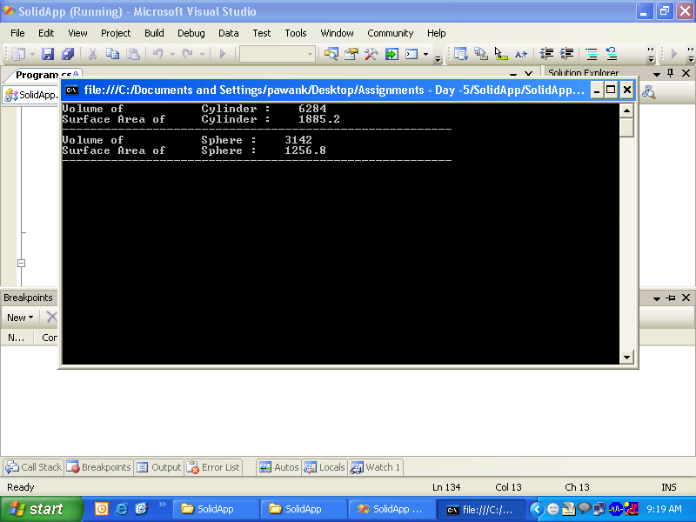

Assignment 3

**Objectives:**

1. To understand all string operations.

**Problem Description:**

1. Create a console application which takes input as two strings.
2. Create a menu which has String Operations as menu Items as shown in given screen shot.

g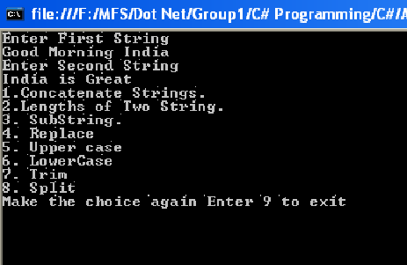`

1. Perform all the operations mentioned on entered strings properly.